**The first Paraparaumu Bridge Olympics**

*WOW! Who* is talking about anything else! What a spectacle!

On Sunday, the 11th of August, 2024, representatives of twenty-two countries came together to contest the first Paraparaumu Bridge Olympic Games.

It was a fitting time, just as another Olympic Games came to a close half a world away. Which event was the greater, more fabulous, more remarkable Games? I’ll leave that for you to decide.

At day’s end, the valiant competitors gathered for a photo:

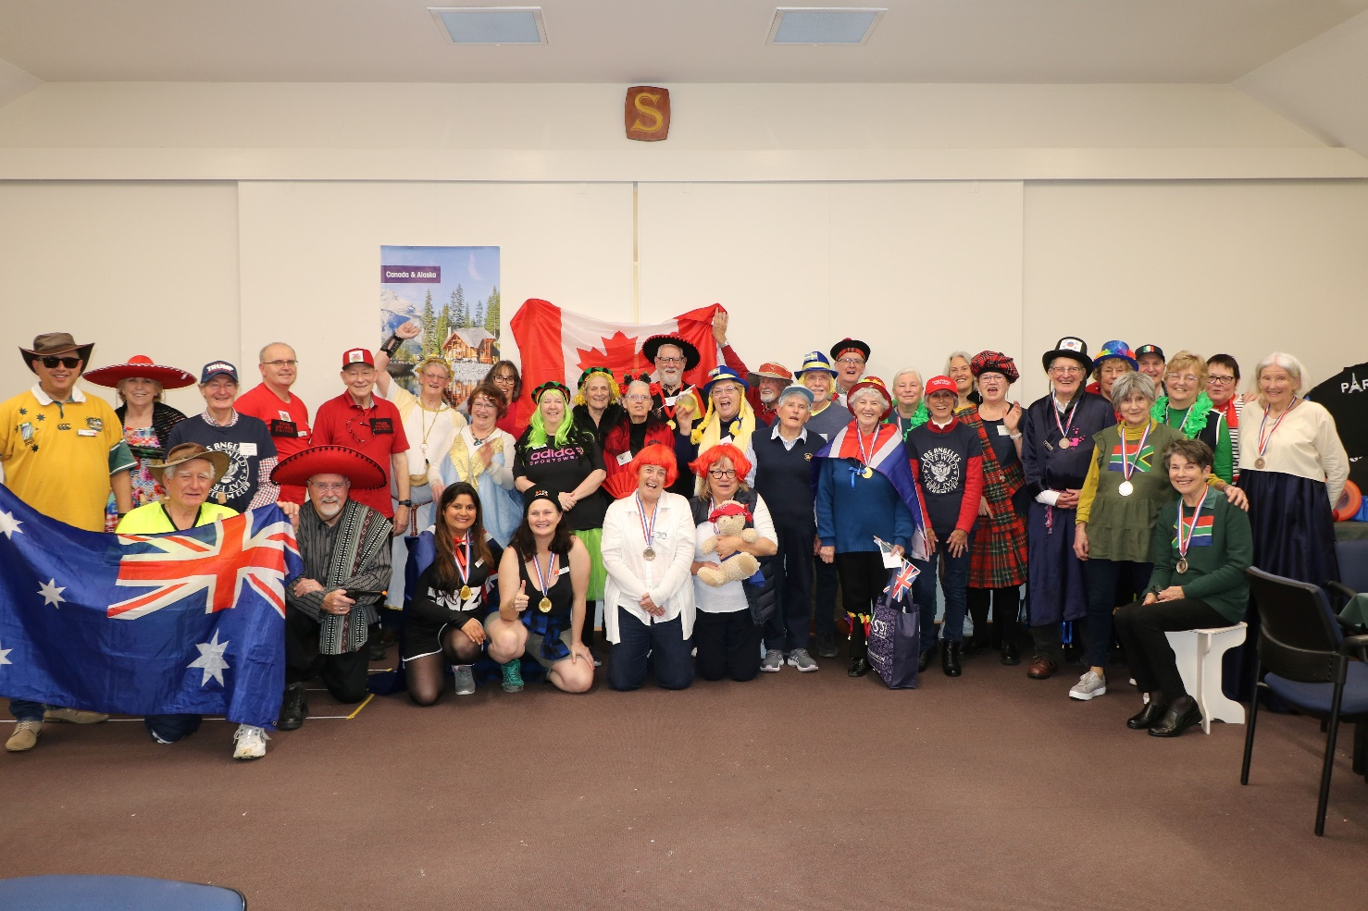

They all look happy, and so they should – after feasting on the wide variety of marvellous food offerings from the countries taking part and imbibing the quality wine and drinks for which our Paraparaumu Club is justly famous.

Let’s have a closer look at some of our competitors.

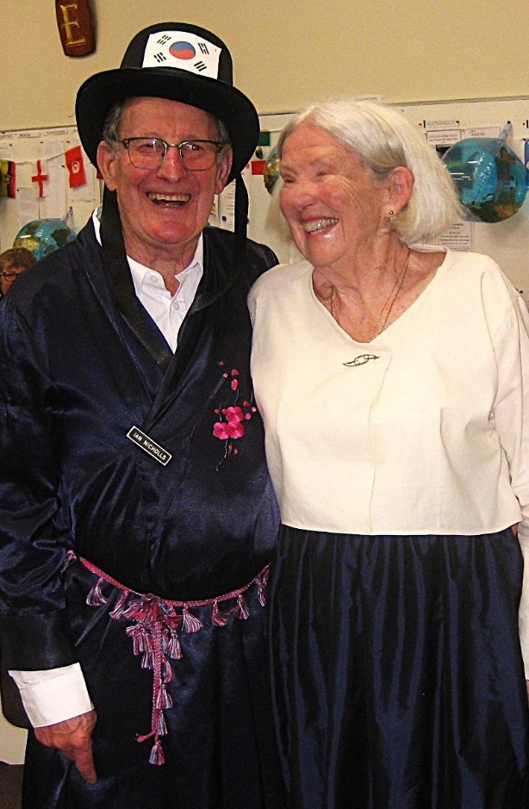Winners of the prize for **best costume**, Ian Nicholls and Margaret Norrish, representing South Korea.

If you didn’t notice, Ian *was* carrying a sword. This fact may or may not have influenced the judge.

The costume display of the participating countries was marvellous and a wonder to behold, a demonstration of the incredible effort and care that our competitors took to dress themselves for the day.

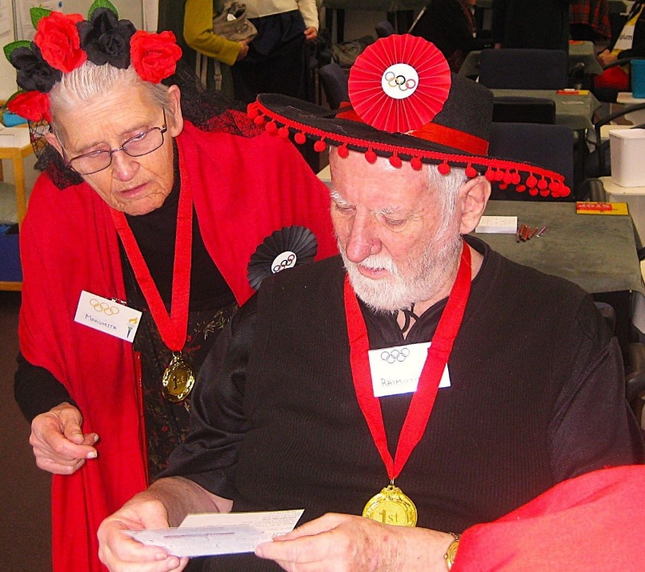Here’s Ray and Margaret Cachemaille, representing Spain, resplendent in red and black, looking as though they could launch into a fiery flamenco dance at any time.

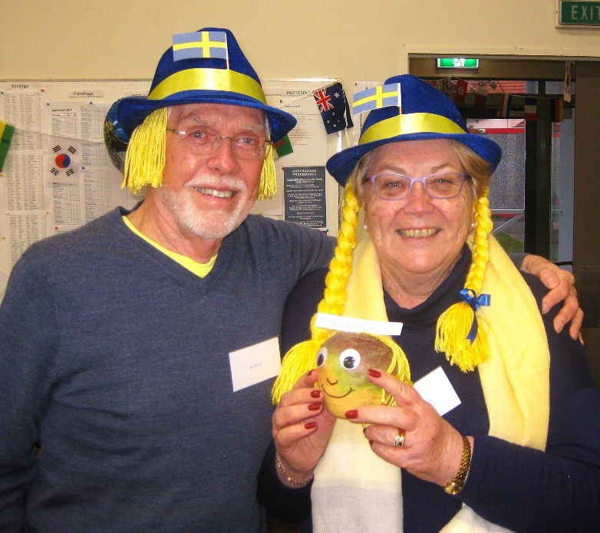And here are our competitors from Sweden, Brian and Linda Pender, sporting the golden locks common to the Swedes.

Speaking of Swedes, Linda is carrying Sven, winner of the **best mascot** prize, the only true swede among this trio.

Traditional border rivals, England and Scotland, were represented by Pauline Reid & Lucy O’Regan, and Keith & Marg Lees.

I hear the battle at the table was just as fierce as on the fields of Bannockburn in 1314, when England’s King Edward II met Scotland’s King, Robert the Bruce. I’d expect nothing less.

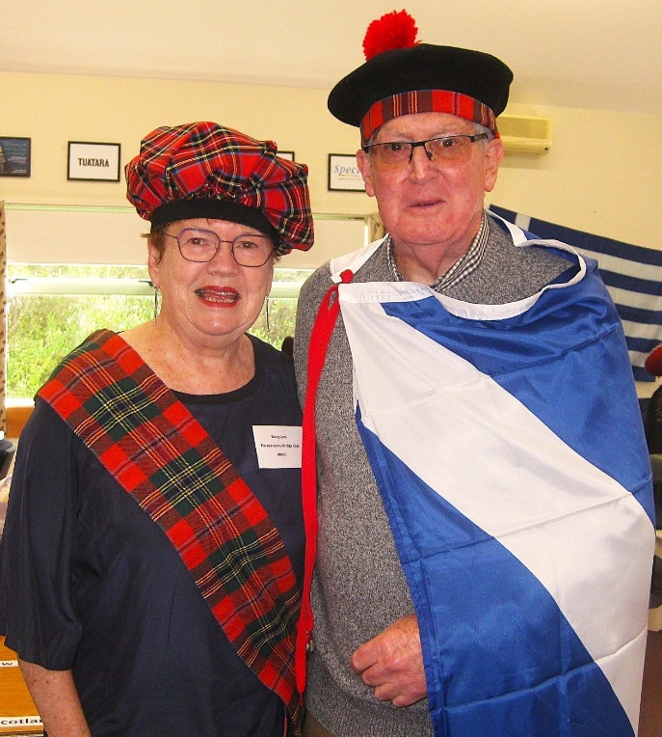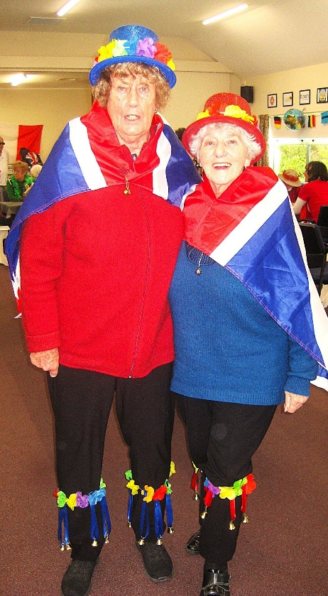

After a hotly contested first round of Bridge, four winning pairs emerged to go into the final competition round.

Top NS pair were **Yvonne Rowe and Lyn Dash**. 2nd NS were **Vikki Clarke and Kay Matheson.**

Top EW pair were **Pauline Reid and Lucy O’Regan**. 2nd EW were **Margaret Norrish and Ian Nicholls**.

Both EW winning pairs we’ve already seen above.

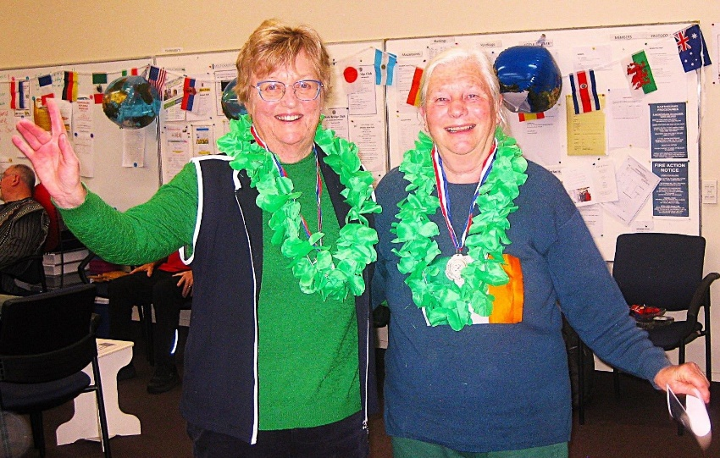Here are our NS winners.

Yvonne and Lyn represented Ireland. Somehow they seem to have picked up some green Hawaiian leis, but being bonny Irish lasses, the leis just fit right in.

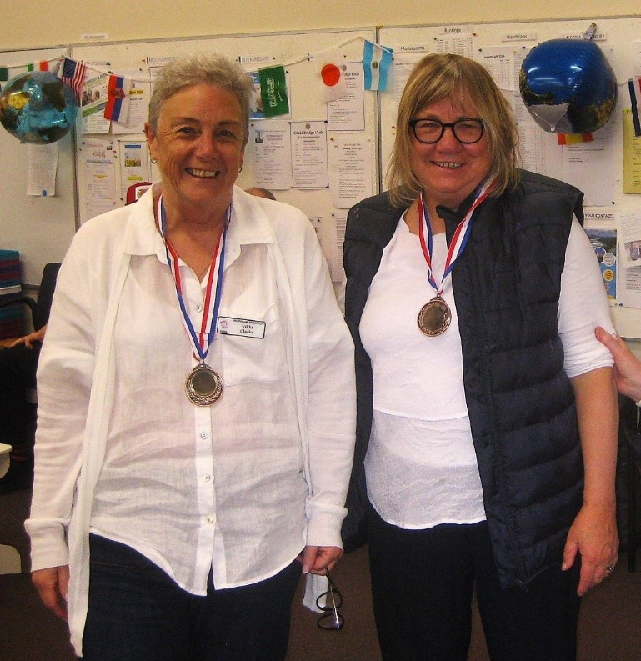Our Italian representatives, Vikki and Kay, are new to the game but already performing well and are obviously destined for great things.

Vikki was in the learner’s class last year, and Kay only completed the learner’s classes in June.

Well Done, Italy!

Before we come to the medal winners, an essential item of the day’s proceedings was the food our competitors brought to the table to represent their country. There were a delicious variety of edible offerings not normally seen at the Club, and this amazing fare was much enjoyed at the end of proceedings.

As with the costumes, the food on display showed the care and attention to detail we’ve come to expect from our membership.

Our food judge commended the quality of all the dishes, but awarded the prize for **best food** to the platter from the pair representing India, **Greg and Margie du Bern**. The judge commented that the samosas were tasty, hand-made, and well-crafted with a delicious accompanying sauce. Unfortunately, sorry, we have no photos of the du Berns. Next time.

**Medal Ceremony**

*Disclaimer: It was a deliberate decision to have no podium for this ceremony. Our Health & Safety Officer thought the climbing and dismounting involved (especially to the height necessary for a Gold medal) would introduce an unacceptable injury risk.*

At the end of a gruelling, noisy, heated finals session, our overall winners fronted up to the Medals Ceremony.

The GOLD medal was awarded to:

**Pauline Reid and Lucy O’Regan**

The SILVER medal was awarded to:

**Yvonne Rowe and Lyn Dash**

BRONZE medals were awarded to:

**Ian Nicholls and Margaret Norrish**

**Vikki Clarke and Kay Matheson**

Congratulations to our medal winners. You should be proud.

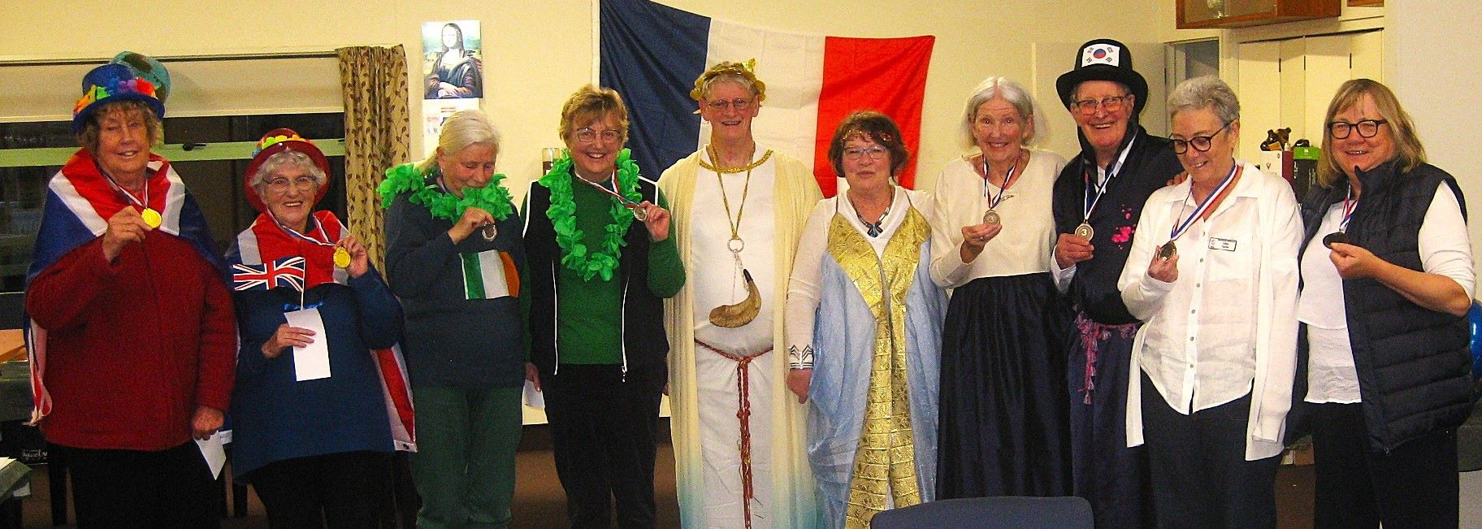Our medal winners, plus a couple of interloper Greek Gods.

**A Shout to those who made it all happen.**

I cannot say this enough. Events such as this are only made possible by the fantastic extra time and effort put in by some of our club volunteers, and they deserve our thanks.

**Linda Pender, Brian Pender, Theresa Cook, and Tina Connell-Pine** decorated the room. From the comments I heard, we all agreed they did a great job. Tina went mad on Temu and bought all the flags and balloons, and Theresa and Linda supplied the sporting equipment.

**Noella Squire** supervised the food and the kitchen, and organised the raffle prizes.

**Helen Edwards** did the scoring, and **Ray & Margaret Cachemaille** handled the bar.

Thanks guys. People like you are the lifeblood of this Club.

This tournament and the day were both very enjoyable and good fun. It’s a pity that the Olympics only comes around every 4 years.

That’s all for now.

Trevor.