Hi Folks,

**July Newsletter**

A few things to celebrate and communicate, so it’s time for another newsletter.

First things first…

**Life Members Sponsored Tournament**

Our Life Members sponsored an in-house tournament on Sunday, June 30th. The room was packed and fizzing with 15 tables. It was a fun-filled afternoon with plenty of prizes and plenty of happy faces – if you think I’m exaggerating, just check out the photos below.

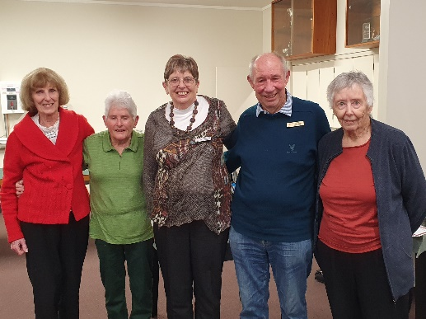We were fortunate to have some Life Members present on the day.

L to R: Helen Edwards, Noella Squire, Jane McArthur, Dale Wills, and Robyn Michelson. Sponsoring Life Members who were present in spirit only were Val Manley and Bill van Waas.

Thanks to all our sponsors.

Top pair for the tournament were Dale Wills and Jane Bradbury.



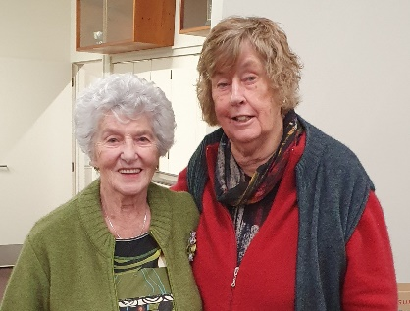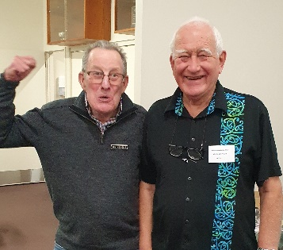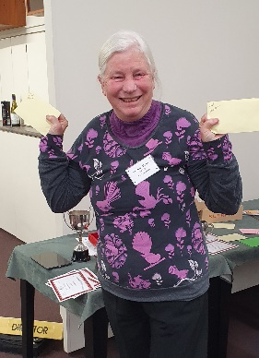I promised heaps of happy faces – take a look at these joyful people and try and tell me Bridge isn’t a fun game.

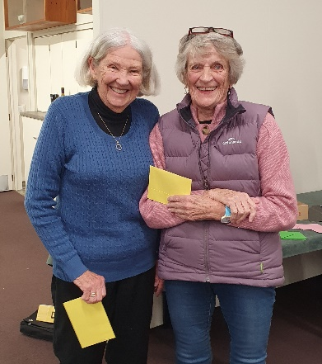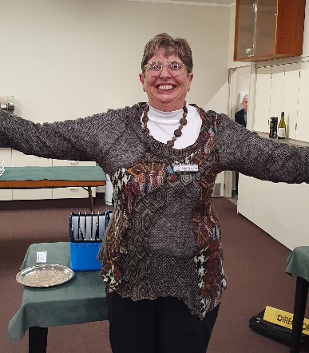 Lucy & Pauline Ian & Alan Yvonne

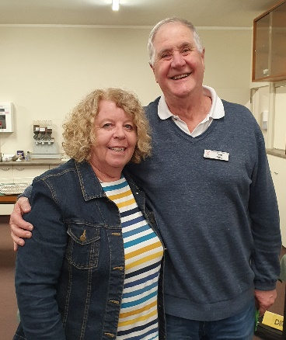

Jane Margaret & Lyn Theresa & Tom

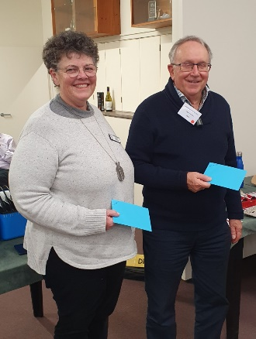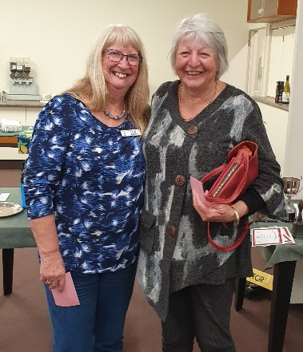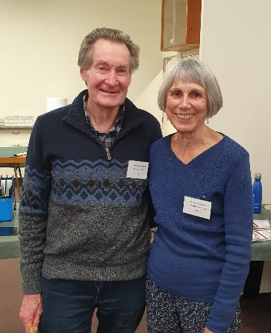

Brett & Sandra Linda & Kay Margie & Greg

Congratulations to our winners and to our players for making the day such an enjoyable one. Thanks to Tournament Organiser Hugh Norton, Director Brian Pender, Scorers Helen Edwards and Jane McArthur, and to Noella Squire for the Kitchen and the Raffles, and Ray & Margaret in the bar. These are the people whose extra efforts make the day run smoothly for the rest of us.

**Subscriptions**

We have received notification from NZ Bridge that they intend to increase the annual affiliation levy they charge for each member. Currently, we pay $20 per member (+GST=$23). We pay this levy quarterly (i.e. $5 per member per quarter).

This is a membership fee paid as part of your annual club subscription.

From 2025, NZ Bridge will increase the levy by $1 per quarter over the following two years.

Accordingly, the committee will introduce a resolution to the AGM in November to increase our annual subscription by $5 to $80 for 2025.

**Visitor to the Club**

A few days ago, a strange noise drew one of our members to the trees behind the club.

There, Linda Pender found a mama possum and her baby sitting comfortably among the trunks. They didn’t seem too much disturbed by the human intrusion.

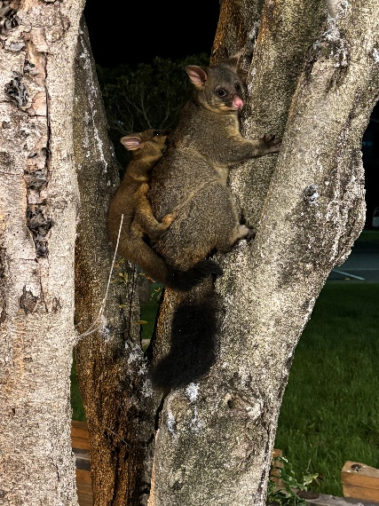

**Addresses**

We hold member’s addresses in our database for contact purposes. These addresses can easily become out of date if changes of address are not notified to the club. If you have changed address recently (say within the last two years) and you may not have notified the club, can you please drop an email to the secretary to let us know your current address.

Thanks.

**Reminders**

Our **Junior Tournament** is on the 21st of June, just over a week away. If you’re a Junior, please consider entering this tournament. There are usually not many entries, so you have a good chance of grabbing tons of B and C masterpoints. We’d like to see a good group of players representing our club at this tournament – we’d love you to walk away with all the prizes – so rise up and enter.

**AND**

See the attached flyer for our **Olympic Tournament** on 11 August.

This promises to be a WOW of a day – one to remember, one for the books – and all that stuff. Get your entries in by 25 July so we can match up pairs and countries and give everyone time to prepare – check out the details on the flyer. The Olympics only comes around once every four years, so let’s make this a day to remember – or have I already said that?

That’s all for now.

Remember: A bad day at the Bridge table is still better than cleaning the house.

Bye. Trevor