Hi Folks,
JUNE NEWSLETTER
Time for another update on happenings and items of interest since our last conversation.

Big Birthday
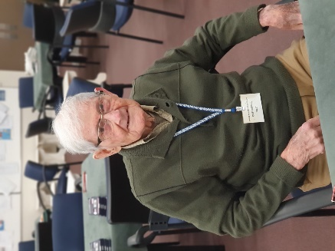
Hearty Congratulations to Cliff Revell, who recently celebrated his ninety-sixth birthday and still going strong!
In case you skipped the number, that’s 96. WOW!
Cliff has been a member since 2013 and is a regular at the Wednesday Social sessions. As I’m sure he would echo, these sessions are a fantastic, friendly, fun way to spend a wet, wintery, Wednesday afternoon.

New Members
We’ve had a huge and very welcome increase in new members from the 2024 Lessons, with sixteen new players joining the club, so if you see new faces across the table, please make them feel welcome. If you can, it would be great if you could offer to partner our new members for future bridge games.
It can be a daunting prospect to start playing Bridge, so please resist the urge to advise better bidding or playing tips – they have enough information whirling in their heads at the moment without adding more.
Let’s show our new members how friendly and patient we all can be.

In-House Tournament
This year, we are holding an In-House Tournament sponsored by our Life Members.
The tournament is an afternoon session starting at 1:30pm on Sunday, 30 June – and it’s FREE. Just bring a plate for after-match nibbles.
I would like to especially invite new members from the lessons, and others who have recently joined the club, to come along to this tournament. It’s fun, not particularly serious, and as I said before – it’s FREE. An enjoyable afternoon is pretty much guaranteed. It’s a great chance to meet members from all sessions you may not have seen before.
News Flash for Learners! As this is the first In-House Tournament since Lessons finished, a special Novice Prize will be awarded to the top-finishing Red-Dotter(s) – if that’s not a magnificent incentive to enter, I don’t know what is!

The Community Centre
The Community Centre building next door to the club has been standing empty for a long time while the Council decided its future. During this time, the appropriately named ‘Meanwhile Space’ between our club and the old Community Centre, has been decorated and developed for community enjoyment. KCDC have been communicating with us while that area has been changing and its been interesting to see the development in progress.
KCDC has now officially decided the building will be demolished in the next few months. As to what will replace it… that’s still to be decided. There’s apparently a small matter of funding hindering that process.
As part of the Meanwhile Space development, our club was assigned a planter box to grow whatever we wanted and I’m pleased to see our box is flourishing thanks to the tender administrations of Tina and Ian.
You may have noticed three brightly coloured boxes with doors on poles have been the latest addition to the area. The box outside our door by the car track will be filled with discontinued books from the library for anyone to take and read. I know many of you are good keen readers, so I’m sure this box will get many visitors from the club, but you’ll have to beat me there to get any good books. Another pole box by our planter box will contain seeds that also may be taken and used by anyone. The third box by the shed will contain various objects produced by arts and crafts organisations in our community.

KHAP Online Sessions
The next three-session Winter series of the Kapiti Horowhenua Area Pairs (KHAP) Tournament will be held online using RealBridge. The first of these sessions is on Thursday, the 20th of June, starting at 7:15pm.
To play in this series, you’ll need to use this link:
https://oceania.realbridge.online/du.html?p=240620222214&q=PLAY20JuneKHAP
The fee is still $8 per session, payable to the same bank account as before – it’s in our Programme book. If you’d like to play but you’re not sure how online Bridge (RealBridge) works, give me a call and I can talk you through it.

Ok. That’s all for now. Bye.
Trevor

