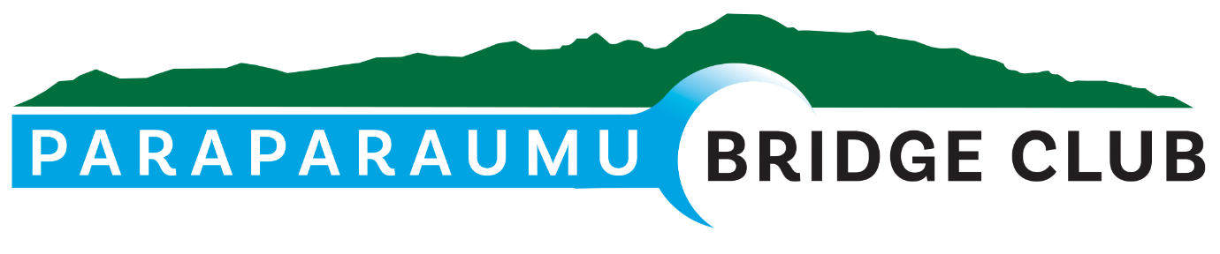
FEBRUARY NEWSLETTER 2024

Hi Folks,
Another Bridge Year is well underway, and the first Newsletter of the year springs to life – fittingly on the last day of February, that rarest of days, the 29th.
Firstly, I would like to introduce you to our new logo at the head of the page. You’ll see our logo popping up on notices, publications, and all sorts of stuff. We’re in the process of arranging the production of some sample shirts, and a design should be available very soon.
The Law Connection Sponsored Pairs.
Our first in-house Sunday competition was held on the 25th of February, and it was hard to miss this pair….
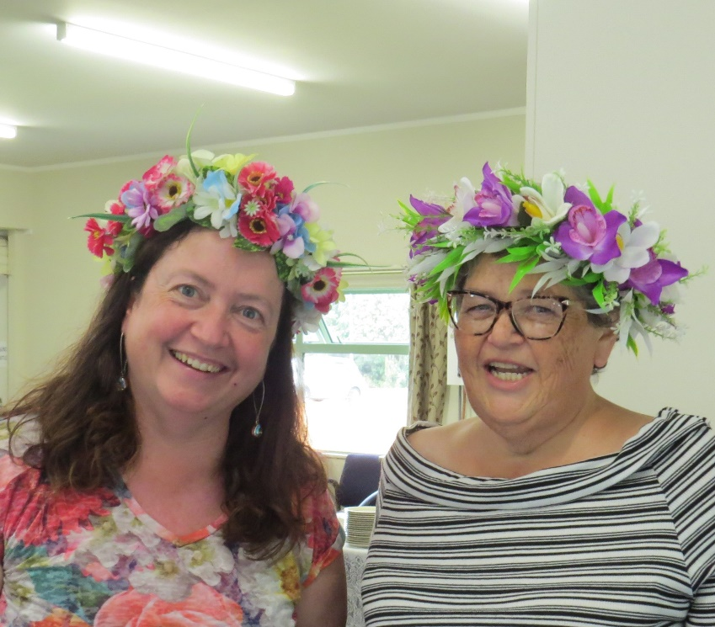
Annette Downey and Sara Enoka brought the flowers inside for all to enjoy. They certainly brightened up the room!

We had a good attendance for this competition – 11 full tables –producing a very enjoyable afternoon’s Bridge.
Thanks to Director Francie Vagg for managing the room so efficiently and Tournament Manager Hugh Norton for organising the day and for promising not to tell any jokes.
The raffle prizes were amazing, and included some freshly-caught blue cod donated by Noella Squires. I understand this cod comes from a special D’Urville Island fishing spot known only to Noella and a select few. Those in the know are sworn to secrecy under pain of… well, I’ll leave that to your imagination.
The winners on the day (with 69.81%! – if only I’d zigged instead of zagged, I’d be in the 70% club now) were Averil Wotton and Sue Wilcox, who were the top East-West pair, seen here with Sponsor Peter Corin of the Law Connection, who presented the prizes.
Well done to our winners.
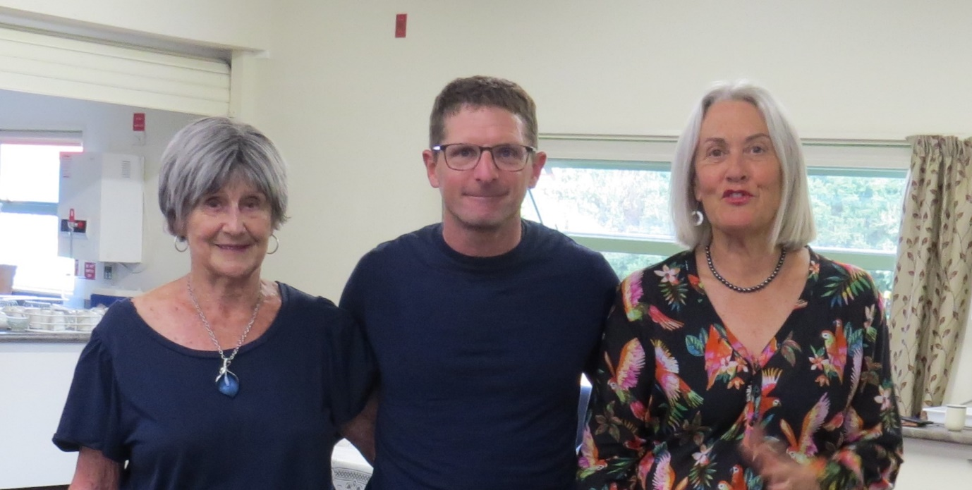
Averil has been seen quite often (too often?) at Peter’s side on these occasions. I’m not saying there are any rumours, but…
Placing second in Section A were Doug Galyer and Jane Bradbury.

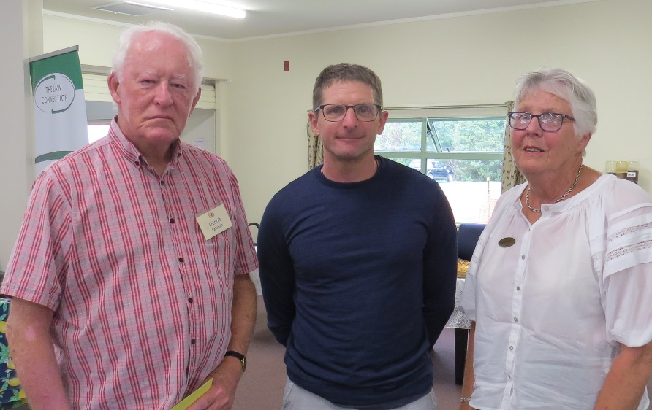
The winners of B Section were Barbara Horner and Dennis Lahman, 4th overall, who were overjoyed with the win but stoically tried not to show it – or maybe I took too long framing the photo. Well done, Dennis and Barbara.
Second in this Section were Anne Kerr and Dennis Kerr.

In Section C, Yvonne Rowe and Christine Keppel triumphed, finishing the day a very respectable 6th overall.
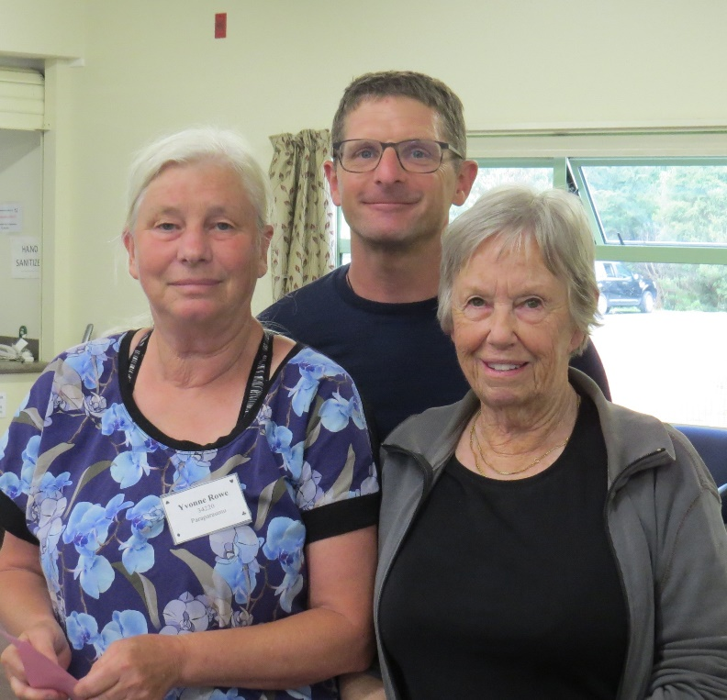
Linzee Inkster and Martin Wrenn were second in this Section, and Tom Tidey and Bob Jennings placed third.

Some very interesting results arose from Section D.
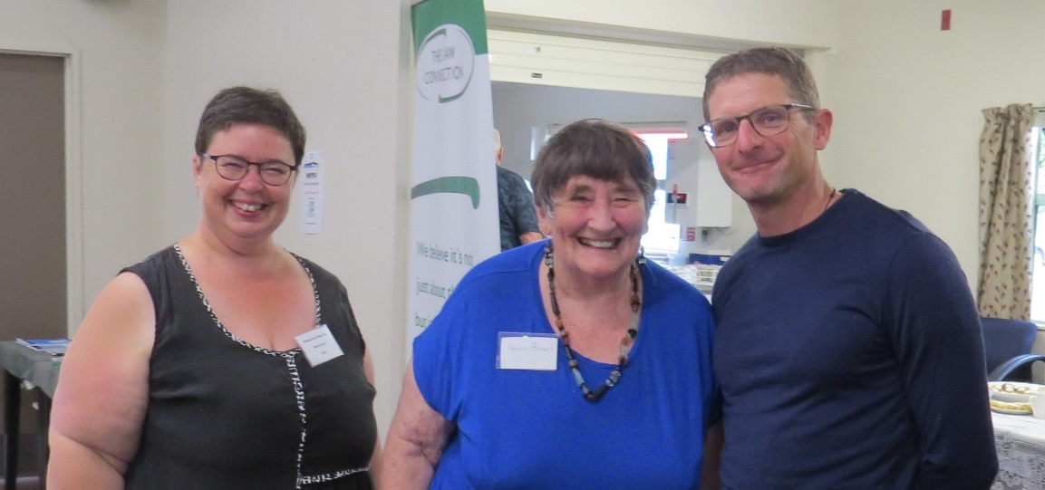
The Section was won by Anne Brunt and Sharon Henry, who were the top North-South pair with 64.81%, and they placed second overall for the competition. Congratulations to you two.
Second in Section D were our flower ladies, Annette Downey and Sara Enoka, who came 7th overall, and third were Rachel Bruce and Margaret Norrish, who finished 8th= overall.
So our section D winners all finished in the top eight on the day. Those are great results and you all should be proud.

A couple of other items of news.
MST cards
Old MST cards will no longer be accepted for refund, so if you find one somewhere, you should frame it because the only way you or your successors will get anything for it now is if your great-grandson is able to sell it to a naïve collector of Paraparaumu Bridge Club memorabilia in about 30 years.
Subscriptions
If you have yet to pay your subscription, please do so ASAP. Subscriptions paid after today will incur a $5 surcharge.
Tuatara Sponsorship
We’ve enjoyed the generosity of Tuatara Breweries with their donated prizes for more than two years. In all, they’ve donated over a thousand dollars worth of prizes.
Unfortunately, the Brewery will be relocating to Upper Hutt later this year, so their prizes will no longer be available. We have one last prize to award, and this will be for the winners of the Tuesday Evening Tuatara Brewery Pairs in October.

And a final Bridge Story…
A Bridge teacher was explaining opening lead protocol to a beginner. “The opening lead should be made face down,” he said. The lady widened her eyes in surprise, then placed her head on the table and led a card face up.

Keep well and keep safe.
Until next time…
Trevor

